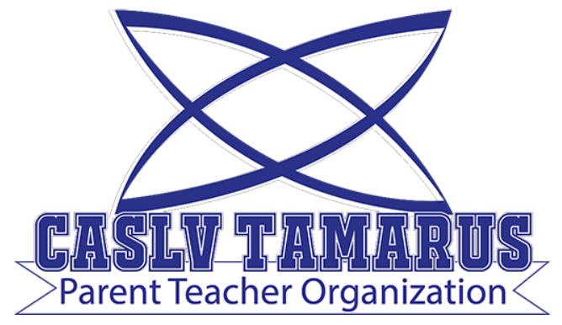 | Meeting Minutes

Meeting Date: November 2, 2021
Meeting Time: 6:00 pm
Meeting Location: Meeting held remotely via zoom
Zoom Invitation and Link: TBA

PRESENT: Jennifer Andreevski, Stacy Wallace, Carryn Warren, Andrea Katotakis
GUESTS: Stephanie, Kelly, Elsa, Cristina, Jennifer

- 6:00pm Call to Order
- 6:05pm Roll Call and Introductions
- 6:06pm Treasurer’s Report
  - $3,318.39, 40$ paypal
  - $2,145 was earned from T-Shirt sales
- 6:07pm Updates/Announcements:
  - Over 300 students attended Trunk or Treat
  - There were 56 orders for hoodies – they will be in by 12th November. There were some size issues – the vendor will contact each buyer affected. They were close to cost so we do not expect much revenue from the sale.
  - The PTO will not have a sale for more spirit shirts for rest of year.
  - End of quarter teacher breakfast – PTO paid for breakfast on staff development day. Possible that we will repeat for end of next quarter. Cost is about $150 to $200.
- 6:12pm Discussion of Potential Activities
  - Fund raiser event or donation drive Nov/Dec to help purchase gifts for faculty/staff. Idea presented for “wrap your teacher.” Other ideas welcome please email tamarus.pto@gmail.com
  - Holiday donations will be used for giftcards, the PTO will survey teachers to see what they would like best
  - A “welcome back” will be scheduled for when teachers return to school after winter break – request from Principal Katotakis to pick Wednesday or Friday of the week of Jan 10th.
- 6:15pm Questions and Answers session with Principal Katotakis -and- Public Comment
  - Principal Katotakis announcements:
    - School is in need of a sound system
    - School is in need of play equipment for outside
    - Tentative celebration for “the Best” on the morning of Friday, Dec 3rd and want the PTO to assist in planning, perhaps “Pastries with Parents”
  - Will there be a science fair this year?
Coral is thinking of manageable ways to run a science fair. Perhaps students choose from guided options. May possibly be online. UNLV will try to do a fair in March that we may participate in. Decisions will be announced.
  - How are MAP scores compared to last year?
They are a bit lower than normal, which was expected. We are working to catch students up. We have a literacy specialist and reading interventionist to help address our concerns.
  - Any plans to change fall break?
We usually try to mirror CCSD, but there is no mention of a change away from Thanksgiving week off.
  - Will Coral mirror the “minimum 50% score” and related policies in effect in CCSD?
Teachers and principals have the freedom to do what is best for our school. We allow students to turn in materials until the end of the quarter, but do allow 0s on assignments. We are looking for a standards based report card in lower level grades.
  - Will Principal’s List continue as is with only students with straight As being awarded?
We are considering other options and need to ensure uniformity.
  - Are we considering inviting press or politicians?
Yes, we are working on that. If anyone has connections please use them.
- Next meeting: December 7, 2021 at 6:00 pm (held remotely)
- 6:45pm Adjournment

