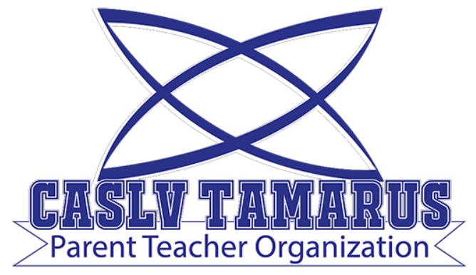 | Meeting Minutes

Meeting Date: March 8, 2022
Meeting Time: 6:00 pm
Meeting Location: Meeting held remotely via zoom
Zoom Invitation and Link: TBA

Your Tamarus PTO:
Jennifer Andreevski (President)
Stacy Wallace (Treasurer)
Carryn Warren (Secretary)

- 6:00pm Call to Order
- 6:03pm Roll Call and Introductions
- 6:03pm Treasurer’s Report
Current account totals $1393.97 at Nevada State Bank, and 10 Gift Cards of $20 each at Target
- 6:04pm Updates/Announcements:
  - PTO purchased playground/recess equipment totaling $1170.31
  - PTO purchased Feb/March/April teacher/staff birthday gift cards totaling $200. 11 more birthdays remain in the school year
  - 2022-2023 Board Members – elections will be held in April or May
- 6:10pm Discussion of Potential and Scheduled Activities
  - Uniform swap – typically don’t have a swap in the spring
  - Ideas for teacher appreciation week (May 2-6)
  - End of 3rd quarter breakfast will be held March 18th
  - Teacher appreciation week, we will be planning for events and things to do that week (May 2nd through 6th). Mid April we will ask for donations, a week or two after Fun Run is completed
  - Sammy’s Restaurant and Bar sent an email regarding a 20% give back, will look more into it
  - Label Daddy Fundraising also offered a fundraiser as well, will also look into
  - Crumble Cookie also offers a fundraising option
- 6:20pm Questions and Answers session with Principal Katotakis
  - Fun run – March 17th through 31st. Will likely use funds for more turf outside, flexible seating and chairs
  - Recess equipment purchases was a hit with teachers. They were hoping for hula-hoops for 4th grade, and some grade levels want “bigger” footballs. Principal K will send a list of requested items to PTO
  - Likely there will be no school wide St. Patrick’s Day (Thurs March 17th) activities
  - We had the lottery on March 1st, which went well. This year was a weighted lottery for families who qualify for Free and Reduced Lunch
  - Book Fair and Nevada Reading week went well, there were a few fun activities and guest speakers. Virtual book fair continues through the 16th
  - There will be a virtual principal chat Tuesday morning 9am where school info is shared and parents can ask question
  - Parent-teacher conferences focused on student academics and attendance
  - State testing for 3rd and 4th coming up in May, along with MAP testing
  - Will be a Orientation before the next school year, typically Thursday or Friday before school starts
- 6:32 No Public Comment
  - Question about calendar
- 6:37pm Meeting Adjourned
Next meeting: April 5th, 2022 at 6:00 pm (held remotely)

