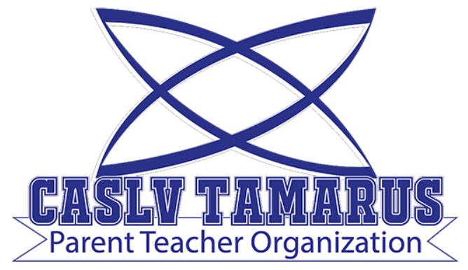 | Meeting Agenda

Meeting Date: May 3, 2022
Meeting Time: 6:00 pm
Meeting Location: Meeting held remotely via zoom
Zoom Invitation and Link: TBA

Your Tamarus PTO:
Jennifer Andreevski (President)
Stacy Wallace (Treasurer)
Carryn Warren (Secretary)

- Call to Order
- Roll Call and Introductions
- Treasurer’s Report
Nevada State Bank $716.32 was carried over from March.
PTO collected $2191.83 for Teacher Appreciation week. Used previous $200 Target gift cards and spent $517.10 of the money collected.
- Updates/Announcements:
  - Teacher Appreciation Week
Monday - open vending machine
Tuesday - candy bars
Wednesday - breakfast
Thursday - ice cream
Friday - survival kits with giftcards
  - Election of Next Year's Board
- Discussion of Potential and Scheduled Activities
  - Possible End-of-Year Breakfast or Lunch - depending on funds
  - Tax-Exempt Application
- Questions and Answers session with Principal Katotakis

- Public Comment
- Next meeting: August 2nd, 2022 at 6:00 pm (held remotely)

